1. Grade Checker
Take a score as input and print the grade based on the following:
90+ : "A"
80-89 : "B"
70-79 : "C"
60-69 : "D"
Below 60 : "F"
here we used a basic if else statement to carry out marks and all.
Solution:
score = int(input("Enter your score: "))
if score >= 90:
print("Grade: A")
elif score >= 80 and score < 89:
print("Grade: B")
elif score >= 70 and score < 79:
print("Grade: C")
elif score >= 60 and score < 69:
print("Grade: D")
else:
print("Grade: F")

Output:
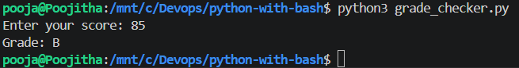
2 Student Grades
Create a dictionary where the keys are student names and the values are their grades. Allow the user to:
Add a new student and grade.
Update an existing student’s grade.
Print all student grades.
Used dictionary and basic operations. Using if else:
Solution:
def add_new():
name = input("enter Student name: ")
grade = input("enter Student grade: ")

student_grades[name] = grade

def update_grade():
name = input("enter Student name: ")
grade = input("enter Student grade: ")

student_grades[name] = grade

def print_all():
for name, grade in student_grades.items():
print(f"{name}: {grade}")

student_grades = {
"pranay":"B+",
"sandhaya": "B",
"min ho": "A"
}

opt = input("Enter your choice: "
"1. Add new student\n"
"2. Update grade\n"
"3. Print all students\n"
"4. Exit\n")

while opt != '4':
if opt =='1':
add_new()
elif opt == '2':
update_grade()
else:
print_all()
opt = input("Enter your choice: "
"1. Add new student\n"
"2. Update grade\n"
"3. Print all students\n"
"4. Exit\n")
Output:
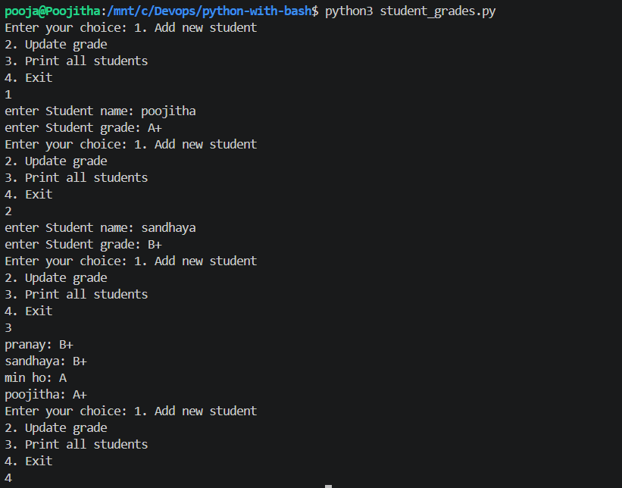
3.Write to a File
Write a program to create a text file and write some content to it.

Using file functions like write and open.
Solution:
with open ("simple.txt","w") as file:
file.writelines(["1. Lorem ipsum dolor sit amet \n","2. consectetur adipiscing elit \n","3. sed do eiusmod tempor incididunt ut labore et dolore magna aliqua \n"])
Output:
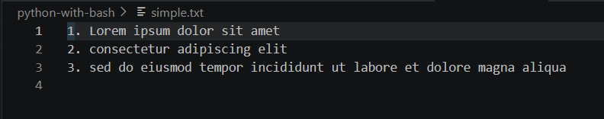
4. Read from a File
We used open in read mode and file.read to read and print to display.
Solution:
with open("simple.txt","r") as f:
print(f.read())
Output:
